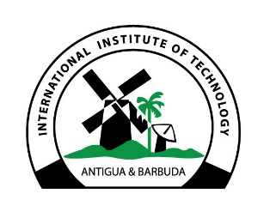

ANTIGUA AND BARBUDA

INTERNATIONAL INSTITUTE OF TECHNOLOGY

ADMISSIONS OFFICE

DEGREE/DIPLOMA REQUEST FORM

Please note that all outstanding balances must be cleared before receiving your degree or diploma and the fee of $100 must be paid.

Student ID: Enter text. Program of Study: Enter text.

Completion Date: Enter text. Number of Classes Completed: Enter text.

Final GPA: Enter text. Student Name: Enter text.

Address: Enter text.

Work: Enter text. Mobile: Enter text. Home: Enter text.

Fees Due: $100 Fees Paid: ☐ Yes ☐ No If Yes, Date Paid: Enter text.

Outstanding Balance: ☐ Yes ☐ No Enter text.

Click or tap here to enter text. Click or tap here to enter text.

Student Signature Date

Click or tap here to enter text. Click or tap here to enter text.

Bursar’s Signature Date

Click or tap here to enter text. Click or tap here to enter text.

Registrar’s Signature Date

